

**UNIVERSITY OF ASIA PACIFIC**

**Department of Computer Science and Engineering**

Course Title – Computer Networks || Lab

Course Code – CSE 320

Group- B2

**Final project: Simple campus networking (UAP)**

Submitted by:

Name – Lasmin Sultana Sorme

Registration no. – 19101086

             Section – B

**Simple Campus Network Design and Implementation**

**Abstract:** The purpose of this project is to design a suitable network system for our university campus. The aim was to design a simple campus network design and implementation with high-quality security and low cost, in such a way that the network device of the university. This project will help to enhance education in developing networking design. There are many devices that were used in designing the network, such as routers, switches, computers, latches, and servers. All devices were connected to each other to make an integrated network system and configured by putting IP addresses on all devices. A simple campus network design is a local area network. The construction of a campus network is the inevitable choice of the development of an information network. The campus network system is a very large and complicated system. It is not only for modern teaching, integrated information management, and office automation series of applications to provide a basic operating platform but also to provide a variety of application services, so that information can be timely and accurate delivery. The campus network construction in the application of network technology is an important branch of LAN technology to build and manage. The campus wired LAN uses a hierarchical design model to break the design up into modular groups or layers. Breaking the design up into layers allows each layer to implement specific functions, which simplifies the network design and therefore the deployment and management of the network. Each layer access, distribution, and core—provides different functionality and capability to the network.

**Introduction:** The Internet and our campus life have been closely linked together. Internet technology began to spread on the campus. As a campus to cultivate the talents of the century, and to achieve network management, teaching is very important. The campus network is a very interactive and professional LAN. The computer network represents a component, especially in how it enhances the functional performance in different fields and organizations, such as companies and schools. A school’s computer network performs so many functions, such as connecting students with the university, faculty, and the library. Most universities today use the network to provide online education by connecting widely dispersed students with their professors directly. For this reason, computer networks play a vital role in the education area by providing efficient communications for the university environment. Multimedia teaching software development platforms, multimedia presentation classrooms, teacher preparation systems, library access systems, test databases, etc., can work through the network. A network is a collection of computers, servers, mainframes, network devices, peripherals, or other devices connected to allow data sharing. An example of a network is the Internet, which connects millions of people around the world. The term network topology describes the relationship of connected devices in terms of a geometric graph. Typical network configurations include bus topology, mesh topology, ring topology, star topology, tree topology, and hybrid topology. A campus network is a building or group of buildings all connected into one enterprise network that consists of many local-area networks (LANs). Need a physical design to connect these switches to each other and also a good logical design to make it work. To build this project, we have to do VLAN, rip2, switches, host, etc. Using cisco packet tracer, we design the simple campus network setup. Campus network will be the University to improve the management level, work efficiency, improve the quality of teaching a powerful means, that is, to solve the information age education problem of the basic tools. Through the University information construction professionals communicate, due to participating in network applications more teachers and students, and contains a large number of multimedia information, so large-capacity, high-speed data transmission is an important requirement for the network. Campus network construction needs are teaching building, dormitory, laboratory building, canteen, and so on the campus network, browse the WEB page, INTERNET visit the corresponding routing strategy. The campus network security requirements are higher, the campus network also has a lot of teaching and file management on the important data, whether it is damaged, lost, or stolen, which will bring great losses. The campus network requirements to achieve the dynamic control of user bandwidth.

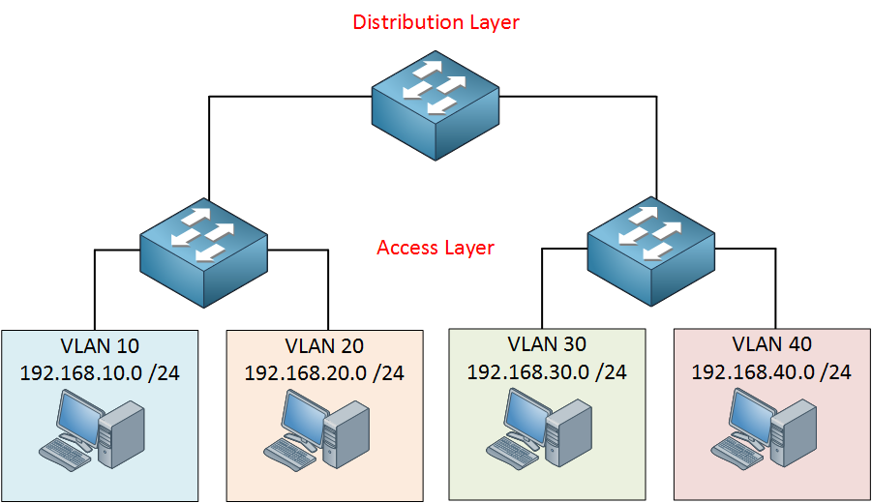

When we design a network setup, there are different types of layers. In our simple campus design, there are three-layer 1st one is the core layer, 2nd layer is distributed layer and the last one is the access layer. The Hierarchical internetworking model is a three-layer model for network design first proposed by Cisco. It divides enterprise networks into three layers: core, distribution, and access layer. A core switch is a network switch that re the backbone of the layered or hierarchy network. These data switches are responsible for routing and data switching at the core layer of the network. The access layer is close to the end-users, these are the switches we use to connect computers, laptops, access points, and much more. The distribution layer is used to combine different accesses layer switches. A hierarchical LAN design includes the following three layers:

• Access layer—provides endpoints and users direct access to the network

• Distribution layer—Aggregates access layers and provides connectivity to services

• Core layer—Provides connectivity between distribution layers for large LAN environments

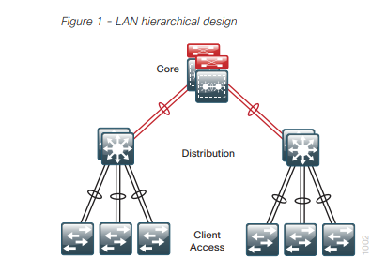

**Problem Statement:** The University of Asia Pacific is a large campus that has two campuses situated 20 miles apart. The university students and staff are distributed in different faculties. These faculties are English, CSE, Civil, EEE, Architecture, Pharmacy, law, and BBA. Each staff member has a PC and students have access to PCs in the lab.

**Requirements:**

1. Create a network topology with main components to support the following:

* UAP Main campus:

**Main Building**: Main Building has ten departments these are Admin, HR, Finance, English, CSE, Civil, EEE, Architecture, Pharmacy, and law. Each department’s PCs are distributed in the building offices and it is expected that they will share some networking equipment (here VLAN is expected). The CSE Department Hosts the University Web and Other Servers**.** There is also an email server hosted externally on the cloud.

* RH campus:

Student lab and DBA (Both are separate are situated on separate floors)

b. We will be expected to configure the core devices and few and devices to provide end-to-end connectivity and access to the internal servers and the external server.

1. Each department is expected to be on its own separate IP network.

2. The switches should be configured with appropriate VLAN’s and security settings.

3. RIPv2 will be used to provide routing for the routers in the internal network and static routing for the external server.

4. The devices in building A will be expected to accrue dynamic IP addresses from a router-based DHCP server.

First, I have to do plan, design, and prototype the network topology for University of Asia Pacific network using Cisco Packet Tracer. I configured the following set up in packet Tracer the network with appropriate settings to achieve the connectivity and functionalities specified according to the requirements. I choose all devices and set the connection wire between the devices (Router to Router, Router to switch, Router to server, switch to pc, switch to printer etc.) Separately design the main building, RH campus and cloud. Then I place the note all IP address in cisco packet tracer.

**UAP MAIN CAMPUS Design**

Here we design the UAP MAIN CAMPUS Building where seven departments are situated including Admin, HR, and Finance departments. Each department is connected with its own pc, printer, and server. They can send and receive messages to another. There is also an Email Server that is hosted externally on the cloud.

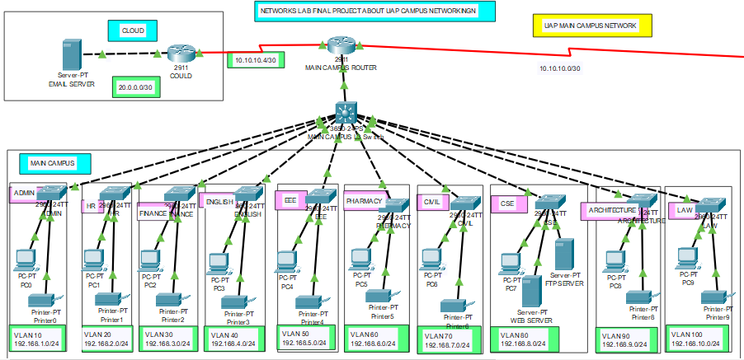

**RH CAMPUS NETWORK DESIGN**

RH campus is another campus of UAP. Here we design the RH campus network. RH campus is a Branch Campus. RH Campus have divided into Two Parts. There are student labs and the DBA department. They are connected with their own PC, Printer, and server. They can send and receive messages to another.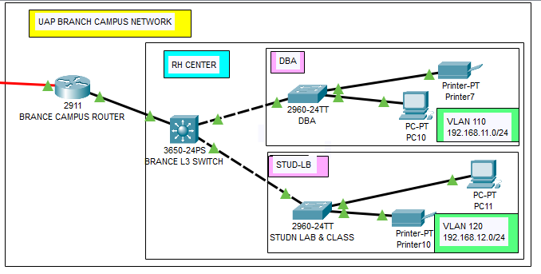

Now we put IP address for each department. Each department is expected to be on its own separate IP network. The switches should be configured with appropriate VLAN’s and security settings.

**Network addresses for Main Building:**

|  |  |  |
| --- | --- | --- |
| Department | VLAN | Network address |
| Admin | 10 | 192.168.1.0/24 |
| HR | 20 | 192.168.2.0/24 |
| Finance | 30 | 192.168.3.0/24 |
| English | 40 | 192.168.4.0/24 |
| EEE | 50 | 192.168.5.0/24 |
| Pharmacy | 60 | 192.168.6.0/24 |
| Civil | 70 | 192.168.7.0/24 |
| CSE | 80 | 192.168.8.0/24 |
| Architecture | 90 | 192.168.9.0/24 |
| Law | 100 | 192.168.10.0/24 |

**Network addresses for RH Campus:**

|  |  |  |
| --- | --- | --- |
| DEPARTMENT | VLAN | Network address |
| BBA | 110 | 192.168.11.0/24 |
| STUDENT LAB | 120 | 192.168.12.0/24 |

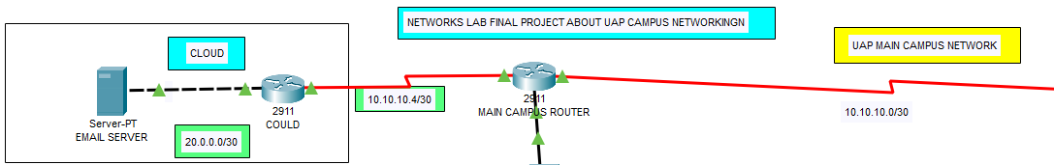

|  |  |
| --- | --- |
| UAP CAMPUS TO CLOUD | 10.10.10.4/30 |
| CLOUD TO SERVER | 20.0.0.0/30 |
| UAP CAMPUS TO RH CAMPUS | 10.10.10.0/30 |

**CONFIGURATION:**

Here, firstly we configure all routers, then we configure the VLAN and we have to do DHCP service. Router configuration: Specifies the correct IP addresses and route settings, etc. Host configuration: Sets up a network connection on a host computer/laptop by logging the default network settings, such as IP address, proxy, network name, and ID/password, to enable network connection and communication.

---Main Router ---

en

conf t

int gig0/0

no shutdown

int se0/1/0

no shutdown

int se0/1/1

no shutdown

do wr

---Cloud Router--

en

conf t

int gig0/0 //router configuration

no shutdown

int se0/1/0

no shutdown

do wr

---RH Router---

en

conf t

int gig0/0

no shutdown

int se0/1/0

no shutdown

do wr

---Main Router clock rate---

int se0/1/0

clock rate 64000

int se0/1/1

clock rate 64000

do wr

exit

**VLAN CONFIGURATION:**

A VLAN (virtual LAN) is a subnetwork which can group together collections of devices on separate physical local area networks (LANs). A LAN is a group of computers and devices that share a communications line or wireless link to a server within the same geographical area.

Here switch 1-12 we configure the VLAN CONFIGURATION.

switch 1

en

conf t

int range fa0/1-24 //code FOR VLAN CONFIGURATION

switchport mode access

switchport access vlan 10

do wr

Same code will be applicable for switch 1-12. We repeatedly doing same code for every switch.

After complete the VLAN Configuration then configure port area.

port area (1)

en

conf t

int gig1/0/2

switchport mode access

switchport access vlan 10

The distribution layer switch should accessible to all VLAN port numbers. An IP address, or Internet Protocol address, is a series of numbers that identifies any device on a network. Computers use IP addresses to communicate with each other both over the internet as well as on other networks.

DHCP server: Dynamic Host Configuration Protocol (DHCP) is a client/server protocol that automatically provides an Internet Protocol (IP) host with its IP address and other related configuration information such as the subnet mask and default gateway.

service dhcp

ip dhcp pool dba-pool

network 192.168.11.0 255.255.255.0

default-router 192.168.11.1

dns-server 192.168.11.1

exit

ip dhcp pool Studlb-pool

network 192.168.12.0 255.255.255.0

default-router 192.168.12.1

dns-server 192.168.12.1

exit

do wr

Finally, we configure the rip version 2. RIPv2 is a classless, distance vector routing protocol as defined in RFC 1723. Being a classless routing protocol, means, it includes the subnet mask with the network addresses in its routing updates. As with other classless routing protocols, RIPv2 supports CIDR supernets, VLSM, and discontinuous networks.

---Rh campus rip V2---

en

conf t

router rip

version 2

network 192.168.11.0

network 192.168.12.0

network 10.10.10.0

exit

---Main campus rip V2---

en

conf t

router rip

version 2

network 10.10.10.0

network 10.10.10.4

network 192.168.1.0

network 192.168.2.0

network 192.168.3.0

network 192.168.4.0

network 192.168.5.0

network 192.168.6.0

network 192.168.7.0

network 192.168.8.0

network 192.168.9.0

network 192.168.10.0

exit

---Cloud rip V2---

en

conf t

router rip

version 2

network 10.10.10.4

network 20.0.0.0

exit

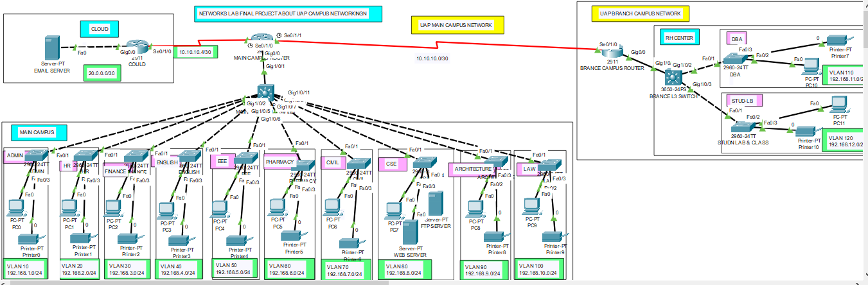

With the advent of the Internet age, the impact of our education is unprecedented, and it also provides a rapid leap for education opportunities, education should be oriented towards modernization, facing the world, facing the future, we must first face the network. Education can only make a combination with the network in order to keep up with the progress and development times. The premise of network education is the construction of the network, and the construction of the campus network is not only the construction of the network hard environment but also must include the campus network maintenance and security, campus network resources, and the effective application of the campus network and other three Link.